

CS241: Software Design and Implementation
FSTE / SCIMS

Final Examination Semester 2 2016

Mode (Face-to-Face)

Total Marks: 100
Duration of Exam: 3 hours + 10 minutes
Reading Time: 10 minutes Writing Time: 3 hours

Instructions:
There are three sections in this paper, with a total of 10 questions This exam is worth 50 % of coursework
The minimum pass mark for this exam is 40 out of 100 marks The question booklet consists of 8 pages
This is a closed book Exam
Write the answers in a separate answer booklet that will be distributed during the exam All the questions are compulsory. There are no choices.

Section A (Short Answers) 30 marks

- A. Explain the term perfective maintenance. ( 2 marks)
Perfective maintenance refers to modifications made to a software system after its delivery to improve its performance, usability, or functionality without correcting faults. It involves refining and enhancing the software based on user feedback or changing requirements, making it more efficient or accommodating new needs.

B. Give two examples for perfective maintenance (2 Marks)
Adding a new feature: Implementing a new report generation function in a financial application based on user demand.
Improving user interface: Redesigning the layout of a mobile app to make it more user-friendly and intuitive.

C. What is retirement in software maintenance? When does it occur? (2 marks)
Retirement in software maintenance occurs when a software system is no longer needed or becomes obsolete. It is the process of phasing out a software product, often because it has been replaced by a newer system or its functionality is no longer required. Retirement typically occurs when:
- The software has reached the end of its lifecycle.
- The organization adopts a new system with better capabilities.
- The cost of maintaining the software exceeds its benefits.

- A. What is the output of the following code fragment? Explain the output. ( 3 marks)
public class example { int i[] = {0};
public static void main(String args[]) { int i[] = {1};
change_i(i); System.out.println(i[0]);
}
public static void change_i(int i[]) { int j[] = {2};
i = j;
}
}

the reference i inside change_i is changed locally, but the array in main remains unaffected. Therefore, the output is 1.

B. What is the output of the following code fragment? Explain the output. (3 marks)
class example { int x;
int y;
String name;
public static void main(String args[]) { example pnt = new example(); System.out.println("pnt is " + pnt.name + " " + pnt.x + " " + pnt.y);
}
}

The statement System.out.println("pnt is " + pnt.name + " " + pnt.x + " " + pnt.y); concatenates and prints the values of name, x, and y.
Since name is null, x is 0, and y is 0, the output will be:
pnt is null 0 0

- Find below a code fragment from a JAVA program and the output generated from the program. You are required to complete the code that would be necessary to be included in the main method so that you would get the output as specified below the code fragment.
public class MainClass {
public static void printArray(Integer[] inputArray) { for (Integer element : inputArray){
System.out.printf("%s ", element); System.out.println();
}
}
public static void printArray(Double[] inputArray) { for (Double element : inputArray){
System.out.printf("%s ", element); System.out.println();
}
}
public static void printArray(Character[] inputArray) { for (Character element : inputArray){
System.out.printf("%s ", element); System.out.println();
}
}
public static void main(String args[]) {
// Create arrays
Integer[] integerArray = {1, 2, 3, 4, 5, 6};
Double[] doubleArray = {1.1, 2.2, 3.3, 4.4, 5.5, 6.6};
Character[] characterArray = {'H', 'E', 'L', 'L', 'O'};

// Print Integer array
System.out.println("Array integerArray contains:");
printArray(integerArray);

// Print Double array
System.out.println("\nArray doubleArray contains:");
printArray(doubleArray);

// Print Character array
System.out.println("\nArray characterArray contains:");
printArray(characterArray);
}

Section B (Long Answers) 40 marks

- Software Implementation
  - What is a logical artefact? (2 marks)
Logical artefact depicts the decision-making flow of control aspects of a product.
  - What is an operational artefact? (2 marks)
Operational artefact performs the actual operations of the product.
  - Observe the following interconnection diagram depicting the organisation of various modules in a software design. Identify the logical and operational artefacts from the diagram. (3 marks)
Logical artefacts: a, b, c, d, g j
Operational artefacts: e, f, h, i, k, l, m
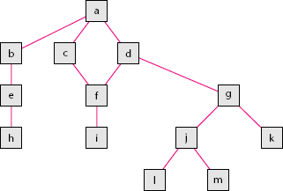

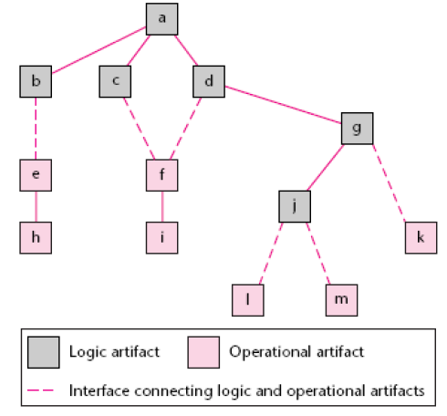
  - Redraw the interconnection diagram to illustrate sandwich integration in software implementation (3 marks)

Software Testing
The following text is a scenario used by a software company that develops software for a Grocery shop.
Consider a software module that is intended to accept the name of a grocery item and a list of the different sizes the item comes in, specified in ounces. The specifications state that the item name is to be alphabetic characters 2 to 15 characters in length. Each size may be a value in the range of 1 to 48, whole numbers only. The sizes are to be entered in ascending order (smaller sizes first). A maximum of five sizes may be entered for each item. The item name is to be entered first, followed by a comma, and then followed by a list of sizes. A comma will be used to separate each size. Spaces (blanks) are to be ignored anywhere in the input.
Identify any 10 equivalence classes for the scenario that would be used by the software team to perform a black-box testing. (10 marks)

In black-box testing, equivalence class partitioning is used to divide input data into valid and invalid classes so that testing can be simplified. For the given scenario, we can identify 10 equivalence classes based on the input constraints for the grocery item name, sizes, and format.
1. Valid Equivalence Classes:
These represent the valid conditions for input data.
- Valid item name length (2 to 15 alphabetic characters):
  - Example: "Apple" (length 5)
- Valid size range (1 to 48, whole numbers only):
  - Example: "12, 24, 36"
- Valid number of sizes (1 to 5 sizes in total):
  - Example: "10, 20, 30"
- Valid ascending order of sizes:
  - Example: "5, 10, 15, 20, 25"
- Valid input format (item name followed by a comma, and sizes separated by commas):
  - Example: "Orange, 10, 20, 30"
2. Invalid Equivalence Classes:
These represent conditions that are outside the valid input ranges or formats and should produce an error.
- Invalid item name length (less than 2 characters):
  - Example: "A" (length 1)
- Invalid item name length (more than 15 characters):
  - Example: "VeryLongItemNameThatExceedsLimits" (length 31)
- Invalid characters in the item name (non-alphabetic characters):
  - Example: "Apple123"
- Invalid size range (sizes less than 1 or greater than 48):
  - Example: "0, 50" (size out of valid range)
- Invalid size order (sizes not in ascending order):
  - Example: "30, 20, 10" (descending order)
Summary of 10 Equivalence Classes:
- Valid item name length (2–15 characters).
- Valid size range (1–48).
- Valid number of sizes (1–5).
- Valid ascending size order.
- Valid input format (name, comma, sizes).
- Invalid item name (less than 2 characters).
- Invalid item name (more than 15 characters).
- Invalid item name (non-alphabetic characters).
- Invalid size (out of range: <1 or >48).
- Invalid size order (not ascending).
These classes help ensure that the software handles valid and invalid inputs correctly, covering both functional and boundary test cases.

JAVA Programming
  - Write a JAVA program to swap two numbers without using a third variable. (5 marks)
public class SwapWithoutThirdVariable {
public static void main(String[] args) {
// Initialize two numbers
int a = 5;
int b = 10;

// Swap the values without using a third variable
a = a + b; // a becomes 15 (5 + 10)
b = a - b; // b becomes 5 (15 - 10)
a = a - b; // a becomes 10 (15 - 5)

// Display the swapped values
System.out.println("After swapping:");
System.out.println("a = " + a);
System.out.println("b = " + b);
}
}

  - The Java program demonstrates how to load the Apache Derby JDBC driver using Class.forName. It first attempts to load the driver class org.apache.derby.jdbc.ClientDriver to establish a JDBC connection. If the driver is successfully found and loaded, it prints "JDBC Class found." If the driver is not found, a ClassNotFoundException is caught, and the program prints "Class not found" followed by the exception details. This ensures that the program can connect to a database using the Derby JDBC driver, or handle the error gracefully if the driver is missing. (5 marks)
import java.sql.*;
public class jdbcConn {
public static void main(String[] args) { try {
Class.forName("org.apache.derby.jdbc.ClientDriver");
}
catch(ClassNotFoundException e) { System.out.println("Class not found "+ e);
}
System.out.println("JDBC Class found");
int no_of_rows = 0; try {
Connection con = DriverManager.getConnection ("jdbc:derby://localhost:1527/testDb","username", "password");
Statement stmt = con.createStatement(); ResultSet rs = stmt.executeQuery ("SELECT * FROM employee");
while (rs.next()) { no_of_rows++;
}
System.out.println("There are "+ no_of_rows
+ " record in the table");
}
catch(SQLException e){
System.out.println("SQL exception occured" + e);
}
}
}

The Java program demonstrates how to load the Apache Derby JDBC driver using `Class.forName` to enable database connectivity. It first attempts to load the `org.apache.derby.jdbc.ClientDriver` class, and if successful, prints "JDBC Class found." If the driver is missing, a `ClassNotFoundException` is caught and the message "Class not found" is printed. The program then establishes a connection to the `testDb` database on localhost, executes a SQL query to select all records from the `employee` table, and counts the number of rows. It prints the record count or handles any `SQLException` that occurs during the process.

Section C (Case Study) 30 marks

- Software Design
Develop UML diagrams for the scenario provided below:

Vending Machine
A vending machine sells small, packaged, ready to eat items (chocolate bars, cookies, candies, etc.). Each item has a price and a name. A customer can buy an item, using a smart card (issued by the vending machine company) to pay for it. No other payment forms (i.e. cash, credit card) are allowed. The smart card records on it the amount of money available. The functions supported by the system are: Sell an item (chooses from a list of items, pay item, distribute item) Recharge the machine, Set up the machine (define items sold and price of items), Monitor the machine (number of items sold, number of items sold per type, total revenue). The system can be used by a customer, a maintenance employee (who recharges items in the machines), an administrator (who sets up the machine).
- Draw a detailed class diagram for the vending machine problem (10 marks)
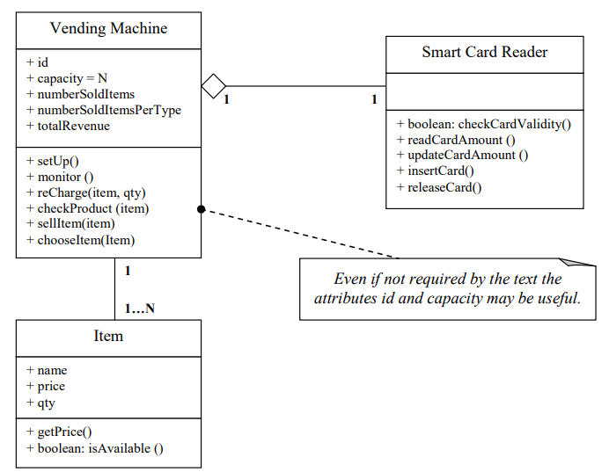

- Draw the use case diagram for the vending machine problem. Provide at least one use case description (10 marks)
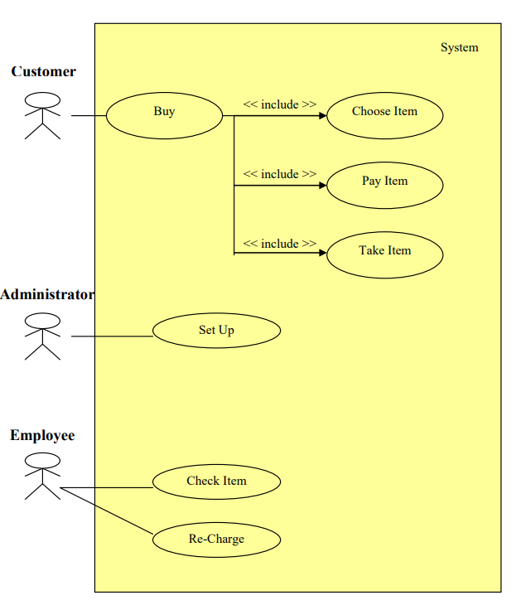
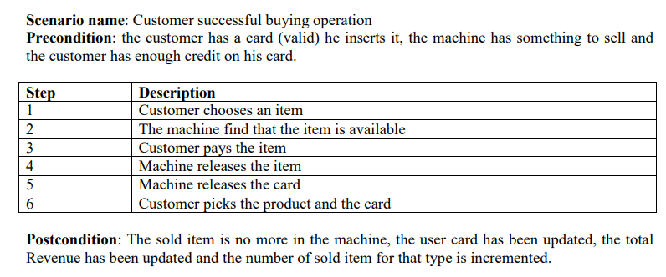
- Draw a sequence diagram for a successful sales procedure in the vending machine (10 marks)

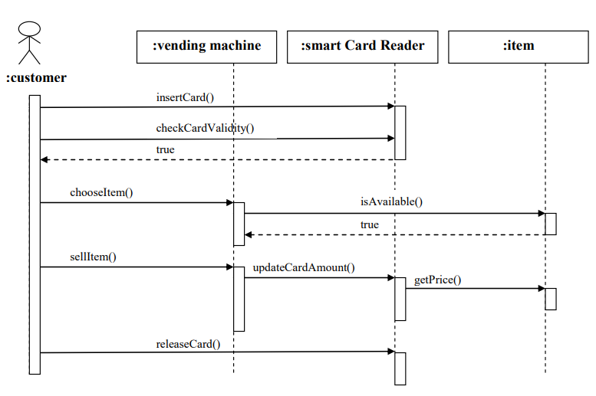

SEE PDF

THE END

